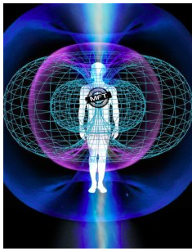
Morphogenic Field (M-Field)

The Morphogenic Field (or M-Field) is a term that refers to the boundary of the energy field of body that is created by the electromagnetic field of the nervous system. It is a well-known fact that every electrical field is accompanied by an electromagnetic field that surrounds it.

The M-Field can be visualized as an outline of energy commonly referred to as the “Torus Energy Pattern”. This common pattern can be found within the universe and represents a basic arrangement in the geometry of life. This torus pattern is a constant within all levels of physics.

It is our contention that the human torus energy pattern, the M-Field, is the origin of the body’s “energy signature”. This M-Field will then shift in both size and symmetry in the presence of other outside energy signatures.

What does the M-Field do? It reads the energy information in our immediate environment and relays those messages back to the physical body. It will expand or contract depending on your current environmental status.

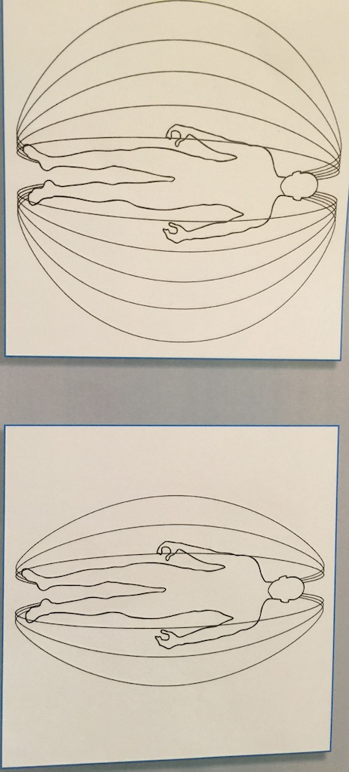
How can you test this field and what does that tell you about health? The primary consideration for the MFT Practitioner is the size of the human torus field. A large M-Field equates with greater health. A balanced M-Field is also important, meaning all sides of the field are equal. This is done by testing or asking the body to react to its environment. If a substance is compatible with the body’s energy signature (a match or attraction) the test muscle stays strong. If it is incompatible (a mismatch or rejection) the test muscle becomes weak.

What might affect the size of my M-Field? There are a number of variables that contribute to the creation of an individual’s energy level including age, diet, emotions, stress, exposure to toxins, hydration and physical fitness.

*Dr. Frank Springob, Bugs in my Brain, Poison on my Plate: Using M-Field Signature Matching to Optimize Your Health

